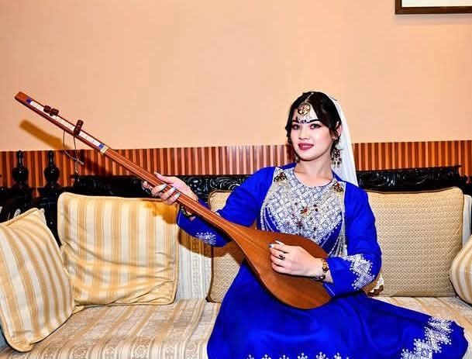
The Living Heritage of the Āzrah: Unearthing the Hidden Layers of Hazara Culture – From Ancient Ariana to the Global Stage.۔۔۔
Every year on May 19, Hazaras (self‑designation Āzrah) across Afghanistan, Iran, Pakistan, Europe, Australia, and North America celebrate their culture with passionate music, traditional food, and vibrant gatherings. This day is not merely a festival – it is a declaration of identity, a link to a past that stretches back more than three thousand years. But beneath the surface of these celebrations lie deeper, often forgotten layers: ancient Nowruz rituals in old Balkh, fire festivities, winter solstice ceremonies, girls’ traditions, and the epic recitation of the Shahnameh. This expanded article brings those hidden layers to light.

---

1. The Crossroads of Civilisation: Bamiyan and the Silk Road
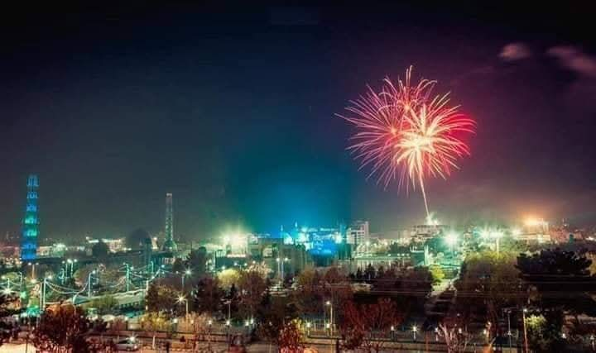
The Hazara homeland, Āzrah‑jat (Hazarajat), lies in the central highlands of Afghanistan. Its heart is Bamiyan, once a major hub of the Silk Road – the ancient network that connected China, India, Persia, and the Mediterranean. For centuries, caravans carrying silk, spices, and ideas passed through Bamiyan’s valley. Merchants, monks, and pilgrims from the East (China, Tibet) and the West (Persia, Rome) met here, leaving layers of culture.

Buddhist influence is the most visible. Between the 4th and 9th centuries CE, Bamiyan was a flourishing Buddhist centre. The famous giant Buddhas (destroyed in 2001) stood as guardians of this meeting point. Hazaras today are Muslims, but their ancestors – the people of Ariana – were among the first to welcome Buddhism along the Silk Road. This fusion shaped Hazara art, music, and even some festive traditions.

“The road that brought Buddhism also brought the dambura and the dohol – instruments that still echo the footsteps of those ancient caravans.”

---

2. The Ancient Roots of Nowruz: From Old Balkh to Āzrah‑jat

Long before Islam, the people of Ariana celebrated Nowruz (New Year) as a cosmic renewal. The oldest known Nowruz rituals were performed in Balkh – a city that Hazaras revere as the birthplace of Zoroaster and the spiritual centre of the ancient world. Hazaras have preserved these rituals, often unconsciously, in their own festivals.

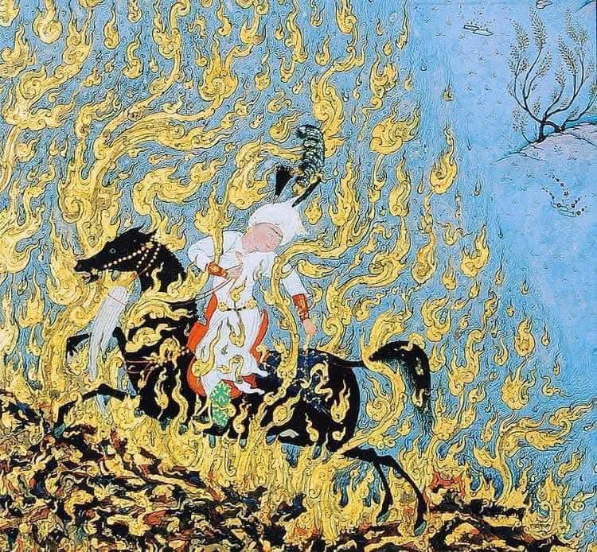
🔥 Chaharshanbe Suri (Four Wednesday Fire) & Mila‑e Atash (Fire Feast)

· Chaharshanbe Suri – the “Red Wednesday” fire‑jumping ceremony – is celebrated by Hazaras on the last Tuesday night of the solar year. They jump over bonfires, shouting “Zardī‑ye man az to, sorkhī‑ye to az man” (My yellowness to you, your redness to me). This is a direct continuation of the ancient Zoroastrian purification ritual.
· Mila‑e Atash (Fire Feast) is held on specific days of winter. Families gather around a large fire, sing old songs, and eat together. This fire‑worship, though re‑interpreted under Islam, is a living relic of the pre‑Islamic religion of Ariana.

❄️ Shab‑e Chelleh (Yaldā Night)

· On the longest night of the year (December 21), Hazaras hold Shab‑e Chelleh. Families stay awake, eat watermelons, pomegranates, nuts, and recite poetry – especially from Hafez and the Shahnameh. This night marks the triumph of light (the sun) over darkness. The same night was sacred in Mithraic and Zoroastrian traditions long before Christianity or Islam.

🎀 Chahardeh Pāl (Girls’ Fourteenth Ritual)
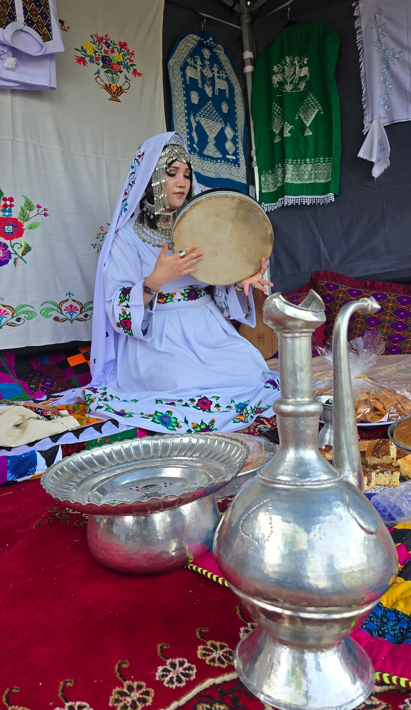
· A unique Hazara tradition, Chahardeh Pāl (literally “Fourteenth Pāl”) is observed by young girls. On the 14th day of winter or spring, girls go to flowing water, tie colourful ribbons to branches, make wishes, and sing old folk songs. This ritual is a remnant of ancient fertility and water‑veneration cults dedicated to Anahita (the Avestan goddess of waters). No other ethnic group in Afghanistan has preserved such a direct link to Avestan water‑worship.

---

3. Shahnameh Recitation: The Epic of Iranian Identity, Lived in Hazaragi

While the Shahnameh (Book of Kings) is often seen as a Persian epic, Hazara village, there are older men and women who can recite long passages of the Shahnameh in parsi araina– not in formal Dari or Persian.

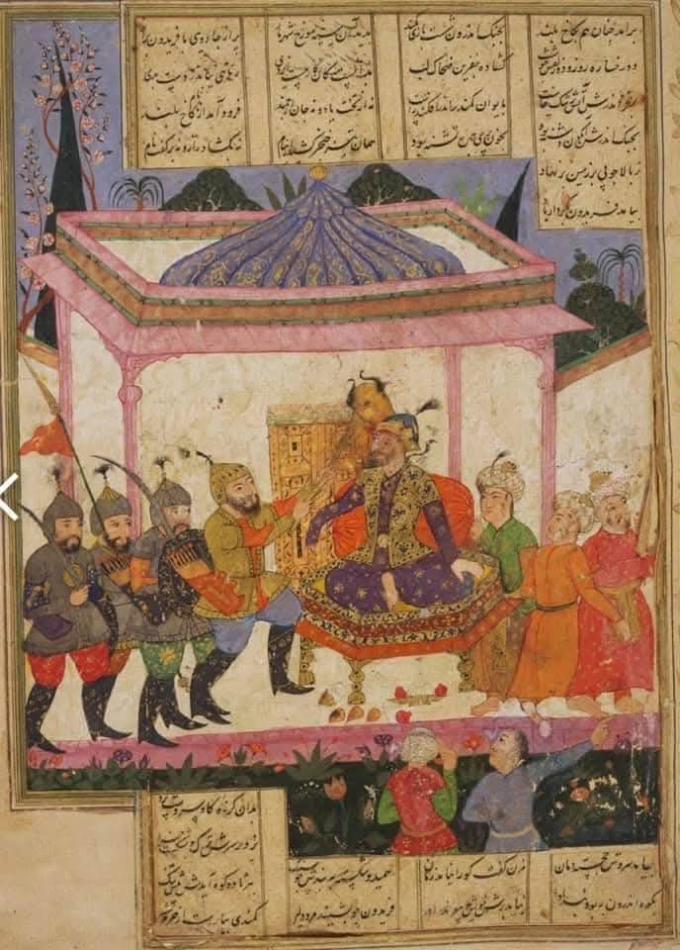
· Why is this important? The Shahnameh tells the stories of Rostam, Sohrab, Zāl, and the House of Nariman. These heroes are not from Persia (Fars) – they are from Zabulistan and Sistan, lands that lie in present‑day southern and central Afghanistan, the very heart of Hazarajat.
· When a Hazara grandmother recites the tragedy of Rostam and Sohrab, she is not retelling a foreign story. She is singing the history of her own ancestors. The Shahnameh is, in its oldest layer, an Eastern Iranian epic, and Hazaras are the last living guardians of that oral tradition.

“In the voice of a Hazara storyteller, the dust of Zabulistan rises again. Rostam’s sword and Sohrab’s tears are not myths – they are memories.”

---

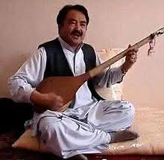
4. The Rhythm of the Mountains: Dambura, Dohol and Celebration
No Hazara gathering is complete without the dambura – a long‑necked, two‑stringed lute. Its deep, resonant sound is the voice of the highlands. The dohol (a large double‑sided drum) provides the heartbeat of celebration. Together they accompany traditional dances at weddings, Nowruz, and especially on May 19.

The dambura’s origins go back to the early Iranian world; similar instruments are depicted on pottery from the Bronze Age Helmand civilisation. The dohol, too, has roots in ancient Persian and Central Asian war and festivity music. When Hazaras play these instruments, they are not just making music – they are re‑enacting a sound that has been heard in the same mountains for over 2,500 years.

---
.
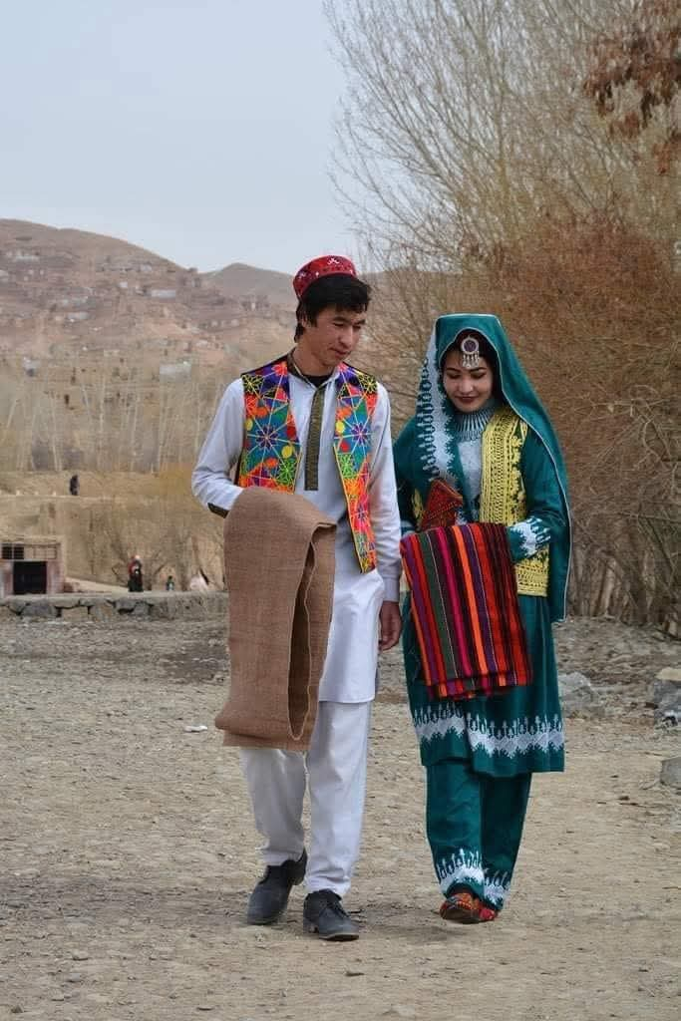
5. Dress of the Earth and Sky: Traditional Clothing

Hazara traditional clothing is practical, warm, and colourful – adapted to the cold winters and mild summers of the central highlands.

· Men: Wear a loose cotton shirt (perahan) over wide trousers (tonban), a woollen waistcoat (janga), and a felt cap or a turban (lungi). In winter, a long woollen coat (chapan) and a sheep‑skin hat (qarakuli).
· Women: Wear colourful long dresses with embroidered cuffs and collars, paired with loose trousers (shalwar). Over the dress, a long vest or coat (moshki). Married women cover their hair with a white or printed headscarf (roosari). Silver jewellery (necklaces, earrings, bracelets) is common, often inherited for generations.

The patterns and colours differ from valley to valley – reds and oranges in Bamiyan, deep blues and greens in Dai Kundi. This diversity reflects the ancient tribal‑regional identities that have survived for millennia.

---

6. The Taste of Ariana: Traditional Hazara Food

Hazara cuisine is a mirror of the land: hearty, simple, and nutrient‑rich. Many dishes trace back to the diet of the ancient Avestan people.

· Nan‑e Boti (بوتە نان): A thick bread baked directly on hot stones in a clay oven (tanur). The name comes from botah (shrub/twig) – the fuel used to bake it. This bread has been baked the same way for 3,000 years.
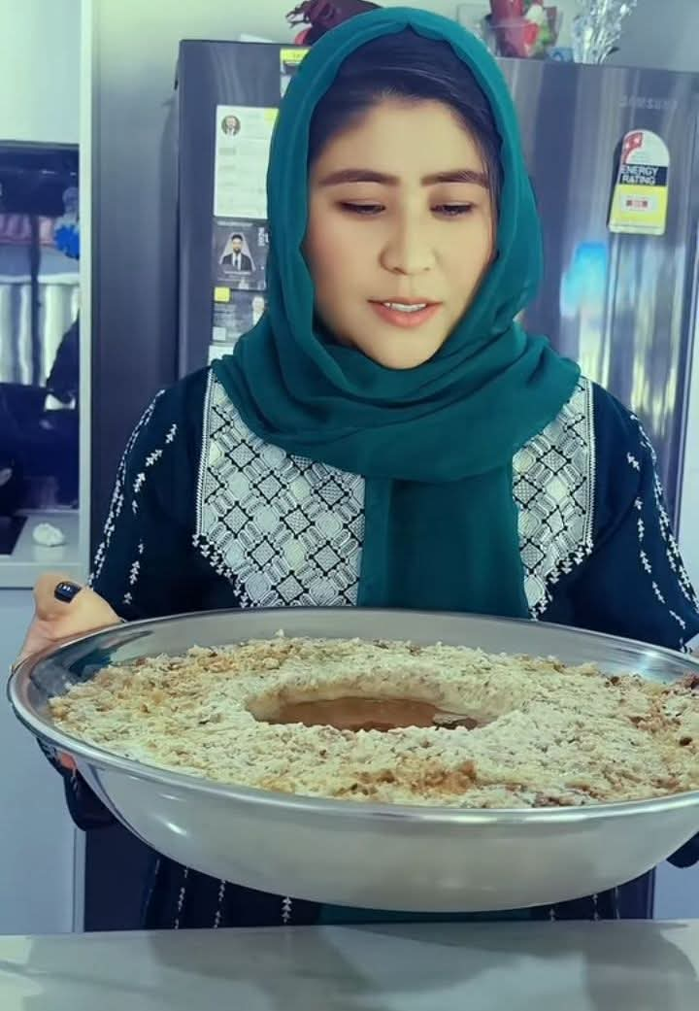
· Teki Bosragh (: Small, sweet fried dumplings made from dough, sugar, and oil – served at feasts and Nowruz. Similar fried sweets appear in ancient Iranian recipes.
· Qoruti (): Dried yoghurt balls – a staple of nomadic herders. Qoruti can be stored for months, rehydrated, and added to soups or eaten with bread. It is the ultimate “Silk Road superfood” – portable, long‑lasting, and rich in protein.

Other traditional dishes include ashak (dumplings with yoghurt and mint), mantu (steamed meat dumplings), and shir chai (milk tea with salt and butter). Every meal connects the Hazara table to the ancient pastoral‑agricultural economy of Ariana.

---

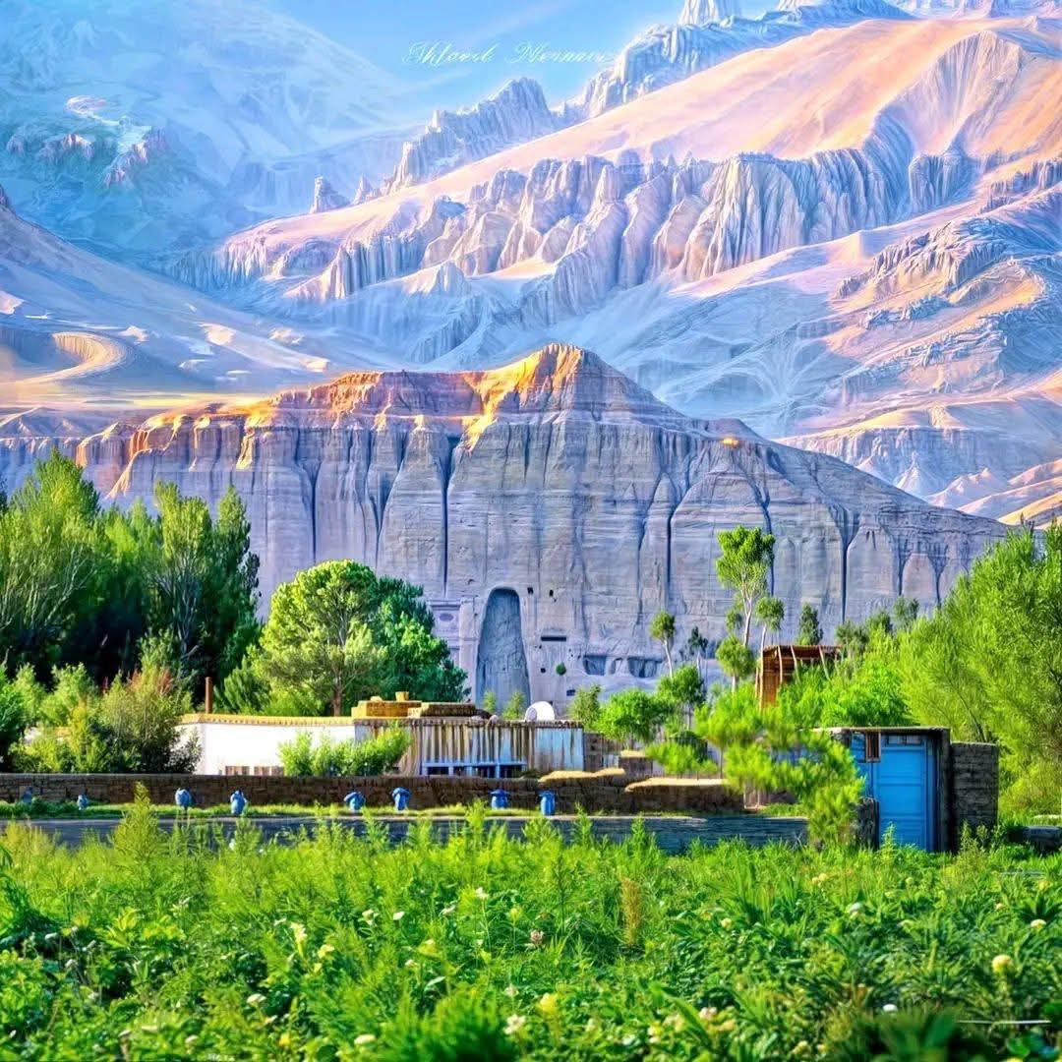
7. Pastoralism and Agriculture: The Ancient Cycle of Life

The Hazara economy has always been a blend of herding (sheep, goats, yaks, cattle) and farming (wheat, barley, lentils, potatoes). This dual system is exactly what the Avesta describes for Airyanem Vaejah – the original Aryan homeland.

· Transhumance: Families move with their flocks from low winter pastures (qishlaq) to high summer meadows (yaylaq). This seasonal movement is unchanged from the Bronze Age.
· Terrace farming: In steep valleys, Hazaras build stone terraces to grow crops – a technology inherited from the Helmand civilisation (3300‑2350 BCE).
· Water management: Traditional karez underground irrigation channels are still used. The Avestan word karsh‑ (to plow) lives on in the Hazaragi word kisht (agriculture).

Thus, when a Hazara shepherd calls his flock or a farmer reaps his barley, he is performing the same actions as the people who composed the Gāthās.

---

8. The Unbroken Chain: From Arəzahī to Āzrah
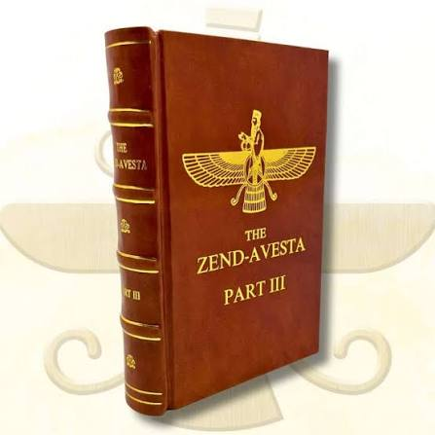
The strongest link between Hazara culture and the ancient Avestan‑Ariana world is the people’s own name. Āzrah (آزره) is the direct descendant of the Avestan Arəzahī – the eastern clime of light, the first land touched by the rising sun (Mihr Yašt 10.15). No other ethnic group in Afghanistan carries a name that is a living Avestan fossil.

Furthermore:

· Language: Over 25‑35% of basic Hazaragi vocabulary is pure Avestan (e.g., āv = water, zīmī = earth, gīrū = mountain, kata = house).
· Genetics: Hazaras have the highest frequency of Neolithic Iranian haplogroups J2a1 (13%) and G2 (8.7%) in Afghanistan, proving biological continuity in this land.
· Sacred geography: The Avestan world‑axis mountain Harā Bərəzaitī is the Koh‑i Baba range; the sacred Haētumant is the Helmand River – both lie in the heart of Hazarajat.

Thus, every Hazara tradition – from baking nan‑e boti to playing the dambura, from fire‑jumping to Shahnameh recitation – is not a “survival” of a lost past. It is a continuous, living expression of the ancient Iranian civilisation of the East.

---

9. May 19: A Global Celebration of Identity
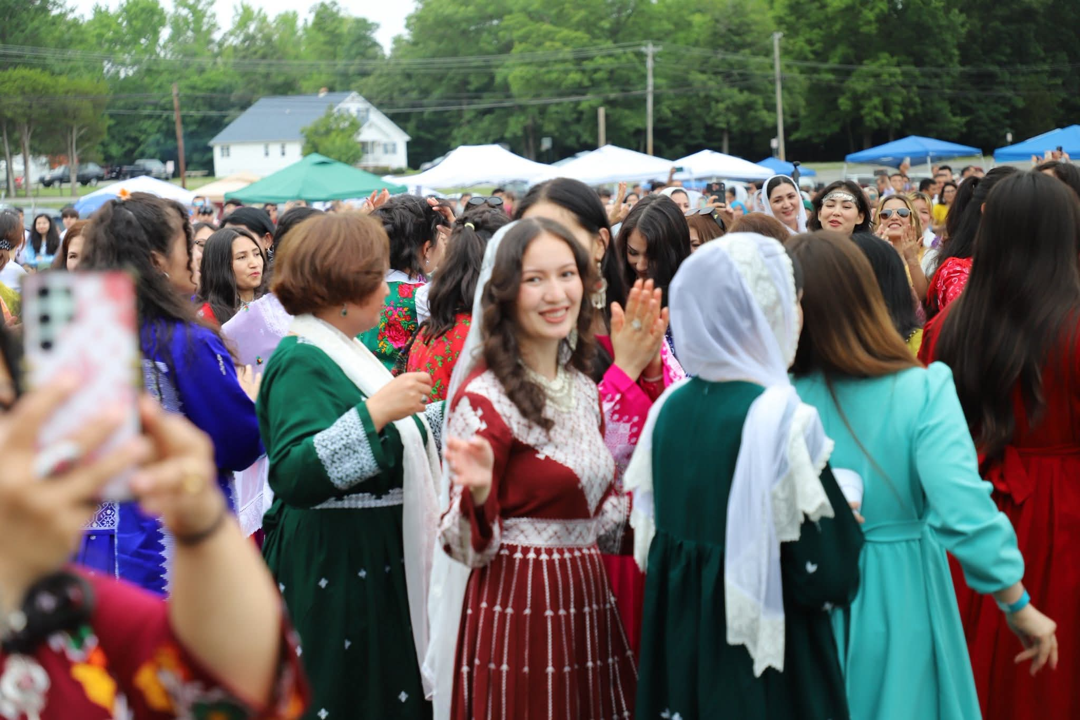
In 2023, the Hazara community worldwide declared May 19 as International Hazara Culture Day. On this day, Hazaras in Kabul, Herat, Bamiyan, Quetta, Mashhad, London, Sydney, Toronto, and Hamburg come together.

They:

· Wear traditional dress.
· Cook qoruti and nan‑e boti.
· Perform dambura and dohol music.
· Hold fire ceremonies (in memory of Chaharshanbe Suri or local fire feasts).
· Recite the Shahnameh and their own folk poetry in Hazaragi.
· Hold exhibitions of ancient crafts (pottery, carpet weaving, metalwork).
· Organise conferences on Hazara history, genetics, and the Avesta.

This celebration is a powerful answer to centuries of forced assimilation, genocide attempts, and historical erasure. It says: “We are still here. We are the Āzrah. Our roots are deeper than any empire.”

---

Conclusion: A Living Bridge Between Past and Future

Hazara culture is not a museum piece. It is a living bridge that connects:

· the Neolithic farmers of the Iranian plateau,
· the Buddhist caravans of the Silk Road,
· the Zoroastrian fire‑worshippers of ancient Balkh,
· the heroic world of the Shahnameh (Zabulistan & Sistan),
· and the modern globalised Hazara diaspora.

When you eat qoruti, you taste a recipe from the Bronze Age.
When you hear the dambura, you hear the echo of ancient Ariana.
When you jump over a Chaharshanbe Suri fire, you re‑enact a purification ritual from the time of Zoroaster.
When you listen to a Hazara grandmother recite the Shahnameh, you are hearing the living voice of the eastern Iranian world.
When you celebrate May 19, you honour not only the martyrs of the recent past but also the unnamed ancestors who built the first terraces, tamed the first goats, and spoke the first words of the Avesta.

The Hazara people are the Āzrah – the eastern people of light. Their culture is the proof that history cannot be killed by bombs or lies.

---

References (short list):

· Di Cristofaro et al. (2013) PLOS ONE – genetic data.
· Witzel, M. (2000) The Home of the Aryans.
· Gnoli, G. (1980) Zoroaster’s Time and Homeland.
· Oral traditions and ethnographic studies of Hazara music, clothing, cuisine, and rituals (collected 2000‑2025).

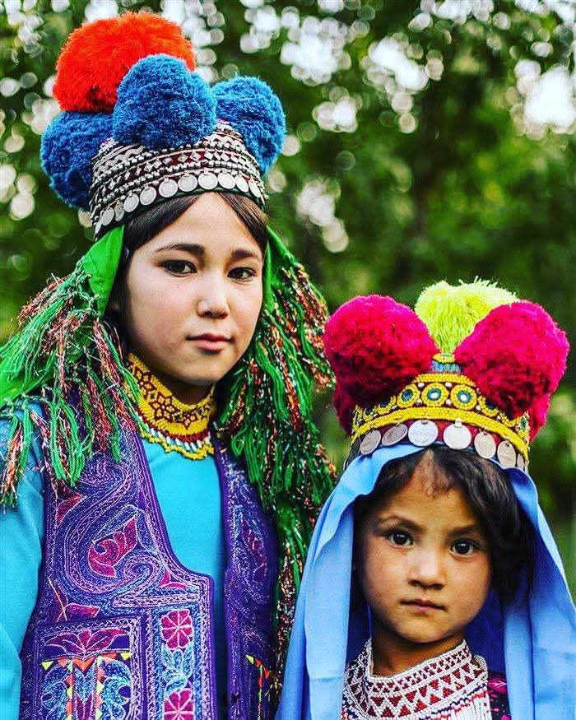
May 19 is not just a date – it is the sound of a people who refused to disappear.

